To: | MAINTENANCE ORGANIZATION | 
Tel: (86) 10 8425 0248
Fax: (86) 10 8425 4819
Date: | July 31, 2026 | Tel: (86) 10 8425 0248  Fax: (86) 10 8425 4819
Pages: | 1 | Tel: (86) 10 8425 0248  Fax: (86) 10 8425 4819

Subject: Notification of CCAR-145 Training Course
Dear Sir/Madam,
Since the initial release in 1988, CCAR Part 145 “Approval of Civil Aircraft Maintenance Organization” has been revised for three times and the English version thereof has also been issued. But for the past few years, CAAC still found that there some misunderstanding of the regulation occurred, such as some maintenance organizations had performed maintenance works beyond the scope of work approved by CAAC and gotten the penalty from CAAC. In order to avoid such situation happened again in the future, also to enhance the communication between CAAC and foreign maintenance organizations and ensure their correct understanding of CCAR-145 requirements, CAMAC plans to hold training course on CCAR-145 continuously for the quality managers from foreign maintenance organizations. This training course is scheduled to be held for the quality managers from your company located in foreign countries for 3 times this year in Beijing. The quality manager from your company is required to attend this training course. For further information on the training course, please refer to the attachments of this letter.
If you have any query or request regarding this training course, please contact the following personnel of Civil Aviation Maintenance Association of China

Mr. Wang Bin at Tel: +86-10-84250248 Fax: +86-10-84254819
Mobile: +86-13911077187
E-mail: wangbin@camac.org.cn
Address: 18B, Tower B, Inter Apartment, No.28 Xibahe Xili, Chaoyang District, Beijing, China ,100028

Best Regards,

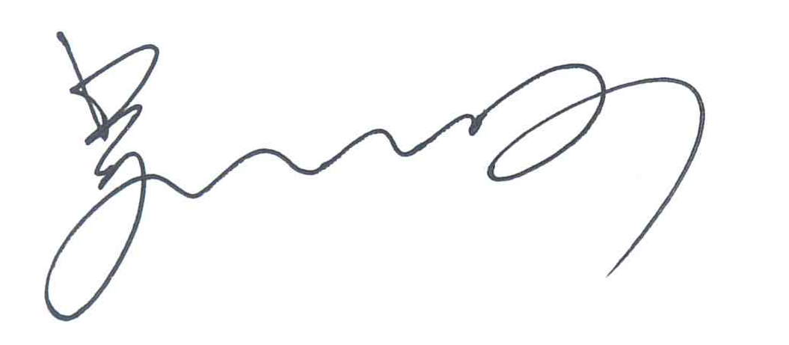
Wu Xijun
General Secretary
Civil Aviation Maintenance Association of China

CCAR145 Training

Contents

The training course will include:
- General introduction to the CAAC organization and regulation systems;
- Introduction of the CCAR-145R3/R4 (including application, acceptance, certification, etc.);
- Questions and Answer.
During this training, CAMAC will provide you more chances to communicate with each other.

Who Should Attend?
Quality manager from CAAC approved maintenance organizations are invited to attend this training. The attendee will be issued with the formal Certificate of Attendance upon the completion of the training course.

Where and When?
Date
 | 1 | May 11-15,2020
 | 2 | September 14-18,2020
 | 3 | October 12-16,2020
The training will take place at the:
KunTai Royal Hotel 昆泰嘉华酒店
B12, Chaoyangmenwai Street, Beijing, P.R. China 中国北京朝阳门外大街乙12号
Tel: +86-10-58285588 Fax: +86-10-58285599

Accommodation
A set of rooms has been reserved at the KunTai Royal Hotel for all attendees, at 900RMB per night for a single room.
Delegates wish to take advantage of these arrangements should contact the hotel directly and make the reservation for one of the rooms being reserved under Civil Aviation Maintenance Association of China.
Accommodation fees should be paid directly to the hotel.
Complete the Hotel Registration Form and send it directly to the hotel;

How to Register
Step 1: Complete the Training Registration Form on http://www.camac.org.cn/bm/en/index.asp

Step 2: Pay the training fee to the bank account of Civil Aviation Maintenance Association of China. Charge to the credit card on-site will not be accepted.

Training Fee
Registration fees for this training course are 2680USD or equivalent RMB (18610RMB) or EURO (2570EUR). The fees cover admission for the entire training course, training materials (hard copy and CDs), daily lunch, refreshments, etc.
Note: The aforementioned registration fees don’t cover the fees for Hotel rate, dinner (except welcome dinner), entertainment or local transportations, those payments will be paid by the attendees. Please notice that the training fee charging by credit card while you’re here will not be accepted.

As previous failure payment happened due to the beneficiary name of the bank were incorrect filling, It’s revealed that the full name of “Civil Aviation Maintenance Association of China” was very hard to be filled into one block. Therefore, as confirmed with Bank of China, the Beneficiary name shall be broke down to two parts to fill:
- “Civil Aviation Maintenance” in name block, and
- “Association of China” in Address block.

To avoid mistake during wire transfer, please do use the following information to pay for training fee:
Beneficiary
Account: | 320756030234
Name: | Civil Aviation Maintenance
Address: | Association of China
Beneficiary Bank
Swift Code: | BKCHCNBJ110
Bank name: | Bank of China Beijing CBD SUB-Branch
Bank address: | 1/F,No.8 Beisanhuan East Road, Chaoyang District, Beijing, China

We highly commended you to listed attendance’s name in remark during make the wire transfer.
Caution: Please notice that do not use “CAMAC” as beneficiary name, that may cause the payment failure.

Training Agenda（Only for reference）
Monday
14:00-16:00 | Registration (at hotel lobby)

Tuesday
08:00-08:20 | Registration (at training classroom)
08:30-08:45 | Opening Remark
09:00-09:30 | Training Module 1 “CAAC General Introduction”
09:30-10:00 | Training Module 2 “CCAR-145 General Introduction”
10:00-10:30 | Break
10:30-11:00 | Training Module 3 “The means of CAAC Maintenance Approval”
11:00-11:45 | Training Module 4 “Privilege and obligation of an Approved MRO”
12:00-14:00 | Lunch
14:00-15:00 | Training Module 5 “The requirements on aviation product and issuance of CAAC maintenance release certificate”
15:00-15:30 | Break& photograph
15:30-16:15 | Training Module 6 “Classification & Limitation of Approved Maintenance Function & Rating”
16:15-16:45 | Training Module 7 “Limitation on Power Plant Rating Approval”
18:00 | Welcome Dinner sponsored by CAAC  (Dress Code: Casual)

Wednesday
08:30-09:30 | Training Module 8 “The basic elements of an approved MRO”
09:30-09:45 | Break
09:45-10:45 | Training Module 8 “The basic elements of an approved MRO” (Continued)
10:45-11:00 | Break
11:00-11:45 | Training Module 8 “The basic elements of an approved MRO” (Continued)
12:00-14:00 | Lunch
14:00-15:00 | Training Module 9 “The management system requirement”
15:00-15:15 | Break
15:15-16:30 | Training Module 10 “Maintenance Criteria”

Thursday
08:30-09:30 | Training Module 11 “Subcontract”
09:30-09:45 | Break
09:45-10:45 | Training Module 12 “Maintenance Record”  Training Module 13 “Maintenance Release Document”  Training Module 14 “Un-airworthy Condition Report”
10:45-11:00 | Break
11:00-11:45 | Training Module 15 “Maintenance Organization Manual”
12:00-14:00 | Lunch
14:00-15:00 | Training Module 16 “Equivalent Means of Compliance”
15:00-15:15 | Break
15:15-16:30 | Training Module 17 “CCAR-145 Certification Process”

Friday
08:30-09:30 | Training Module 17 “How to Fill-in The Forms”
09:30-09:45 | Break
09:45-10:45 | Training Module 17 “Regulatory Updates”
10:45-11:45 | Questions and Answers
12:00-14:00 | Lunch
14:00-15:30 | Training Certificate Issuance Ceremony”

Note: CAMAC may make changes to the agenda upon the circumstances if applicable.


To:昆泰嘉华酒店销售部
 | 昆泰嘉华酒店北京 | 请用英文正楷填写PLEASE FILL IN BLOCK LETTERS
 | KunTai Royal Hotel | 临 时 住 宿 登 记 表  REGISTRATION FROM OF TEMPORARY RESIDENCE
 | 英文姓  Surname |  |  |  |  | 英文名  First Name |  |  | 性别  Sex
 | 中文姓名  Name in Chinese |  |  |  |  | 国籍  Nationality | 生 年  Date of Birth
 | 证件或护照种类  Type of Certificate  Or Passport |  | 证件或护照号码  Certificate or  Passport No. |  |  |  |  | 签证种类  Visa Category
 | 签证有效期  Visa Validity |  |  | 抵达日期  Date of Arrival |  |  | 离店日期  Date of Departure
永久地址
Permanent
Address
 | 工作单位  Place  of work |  |  |  |  |  | 职务  Position
邮件地址
e-mail
 | 房间号码  Room Number |  |  |  | 宾客签字  Guest Signature
操作资料

OPS DATA
正常程序

NORM PROC
不正常程序

ABN PROC
应急程序

EMER PROC
Please complete the Hotel Registration Form and send it directly to the hotel.
Kuntai Royal hotel will send confirmation of reservation to you.
e-mail: reservation@kuntairoyalhotel.com
Tel:+86 10 5828 5522
5828 5533
5828 5544
Fax no.: +86 10 5828 5000

